Assignment for Module 10
The assignment for Module 10 involves problems for schema conversion. Problems 1 to 4 involve the ERD in Figure 1.
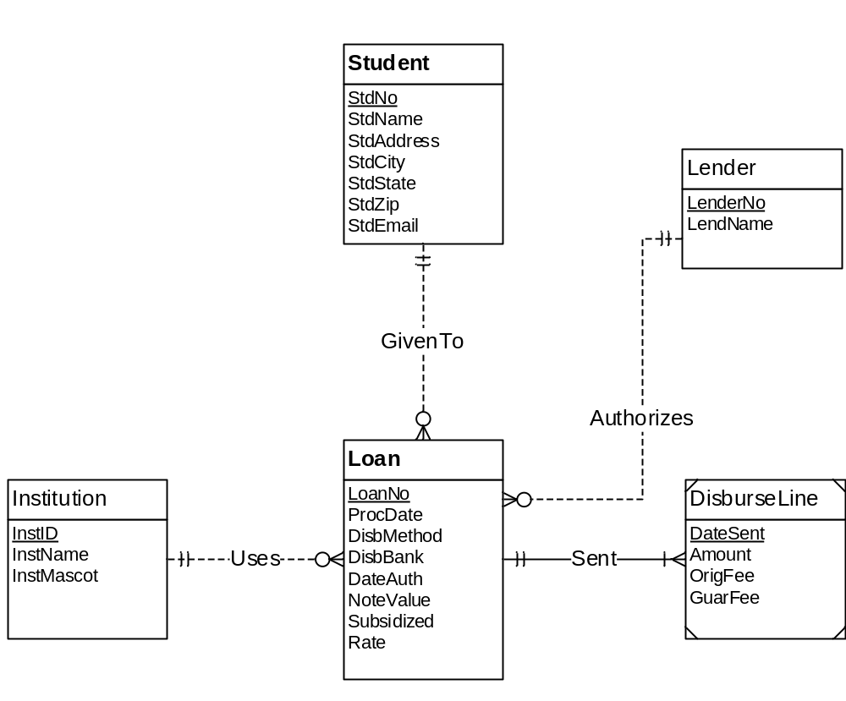
Figure 1: ERD for Problems 1 to 4
There are no M-N relationship in the ERD, thus, M-N conversion rule is not needed.

